Lab Report Format/Template

NAME: _____________________ ROLL NO: _____________
PERIOD: ___________________ DATE: _____________
(The date is when you wrote the lab report NOT when you conducted the experiment)

Lab Report Title Goes Here

- This MUST be descriptive enough so that anyone can determine what the experiment was about just by reading the title.

PURPOSE:

- The purpose is written in complete sentences.

MATERIALS:

- The materials section includes a numbered list of the items you used to perform the experiment.

PROCEDURE:

- The step-by-step procedure you did while conducting the experiment. Remember, you are only listing what you ACTUALLY did during the experiment.

RESULTS (DATA):

- This section includes any qualitative or quantitative data gathered during the experiment. This is where charts, graphs, calculations, formulas, and tables are to be included. You may attach a separate sheet(s) if necessary. All tables, graphs and charts should be labeled appropriately. Do not analyze your data in this section.

ANALYSIS:

- In the analysis, you should summarize your experiment and provide a personal reflection. Discuss what you learned from the lab and how the experiment helped in your understanding of the topic. If your lab did not turn out well, explain what you think went wrong. Why you got the results that you did, what factors could have contributed to the results i.e. human error, conditions were not ideal etc. If you had to do the lab again, what would you do differently? How could you eliminate some of your error?

For Lab Report sample see Appendix A

Appendix A

NAME: Omar Afzal ROLL NO: 10i-0387
PERIOD: 3 Hours DATE: 10-02-2012

Faraday’s Law

PURPOSE:

- To experimentally proof Faraday’s law.

MATERIALS:
Induction Wand | EM-8099
Variable Gap Lab Magnet | EM-8641
Large Rod Stand | ME-8735
45 cm Long Steel Rod | ME-8736
Multi Clamp | SE-9442
Voltage Sensor | CI-6503
Magnetic Field Sensor | CI-6520A
Rotary Motion Sensor | CI-6538
Mass Balance | SE-8723
Meter Stick | SE-7333
ScienceWorkshop 500 Interface | CI-6400
DataStudio Software | CI-6870

PROCEDURE:

Set up

- Put a rod in the stand and clamp the cross-rod to it as shown in Figure 1. Put the Rotary Motion Sensor at the end of the cross-rod.
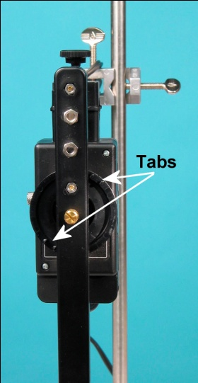
- Attach the coil wand to the Rotary Motion Sensor with the tabs on the 3-step pulley just to the sides of the wand as shown in Figure 2.

- Put the pole plates on the magnet as shown in Figure 3. Adjust the gap between the magnet poles so the coil wand will be able to pass through but put the magnet poles as close together as possible. .

- Adjust the height of the coil so it is in the middle of the magnet. Align the wand from side-to-side so it will swing through the magnet without hitting it.

- Plug the Voltage Sensor into Channel A of the ScienceWorkshop 500 interface. Plug the Rotary Motion Sensor into Channels 1 and 2. Plug the Magnetic Field Sensor into Channel B.

- Plug the Voltage Sensor banana plugs into the banana jacks on the end of the coil wand. Drape the Voltage Sensor wires over the rods.

experimental Steps:

- Click START. With the pole plates on the magnet, use the Magnetic Field Sensor to measure the magnetic field strength between the magnet poles. Click STOP. Note which pole of the magnet is the north pole.

- Click START and pull the coil wand back and let it swing through the magnet. Then click STOP.

- Use the Magnifier Tool to enlarge the portion of the voltage vs. time graph where the coil passed through the magnet.

- Use the mouse to highlight the first peak and find the average voltage.

- Use the Smart Cursor to determine the difference in time from the beginning to the end of the first peak.

RESULTS (DATA):

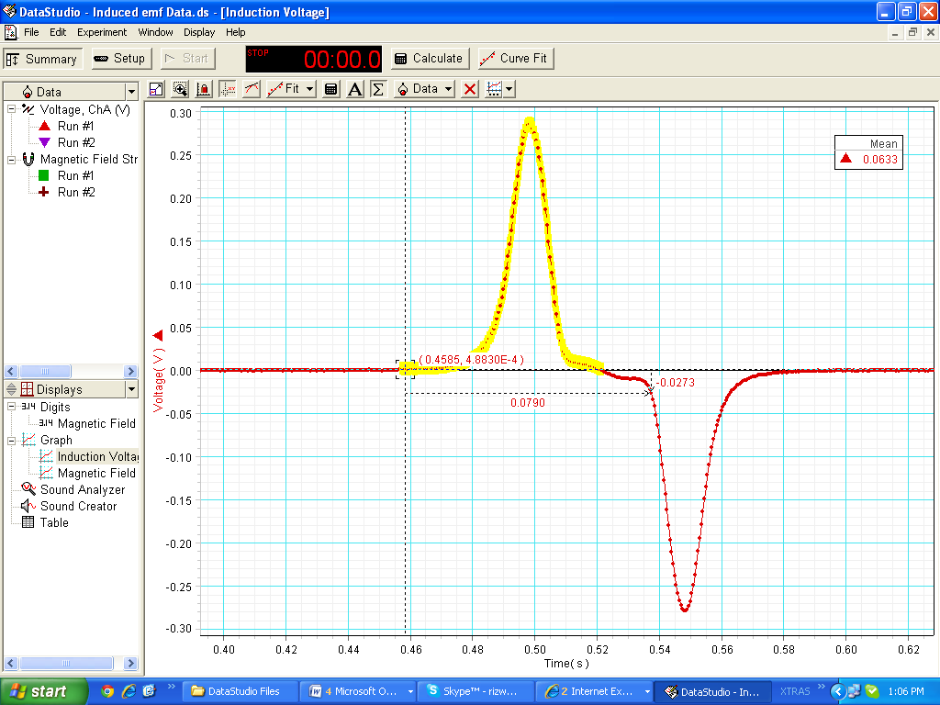

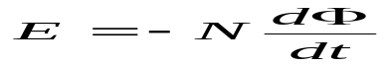
Δt = 0.0629s
r=0.0013m
B(Magnetic Field) = 400 guass=0.04 tesla
N (number of turns of coil)=200
Area of the coil= B.A
A=2.387e-5
E (calculated vale) =0.0675
E (Experimental Value from the Graph) =0.0633
% of error = | calculated value- Experimental value | / Calculated Value x 100
% o error = 6.22%

ANALYSIS:

Its obvious from the graph that the experimental and the calculated values are approximetly same within the error range of 6.22 %. Hence Faraday’s law is proved experimentaly. When the coil is entering the magnetic field, the peak is positive due to negavtive magnetic field according to the Len’s Law. At the center of magnetic field, emf(electro motive force) will be zero because B(magnetic field) and A(Area of the coil) are perpendicular to each other. And their dot product is zero. Hence proving the Faraday’s Law.

